**PHASE 4: ELABORATED IMPLEMENTATION OF PROJECT**

**Name:** Salman Faris .R

**Reg No:** 311623243044

**Department:** B.Tech - Artificial Intelligence and Data Science

**college code :** 3116

**college name :** Misrimal Navajee Munoth Jain Engineering college

**Date of Submission :** 30 - 04 - 2025

# AI Model Development

Overview:

This step focuses on developing advanced AI models that can analyze large datasets to predict the occurrence of natural disasters. The aim is to improve the reliability, accuracy, and responsiveness of the system by integrating various machine learning techniques.

Implementation Details:

* Collect and preprocess massive datasets from global sources such as USGS (United States Geological Survey), IMD (India Meteorological Department), and NASA for different types of natural disasters.
* For earthquake prediction, deep learning models such as CNNs (Convolutional Neural Networks) and LSTMs (Long Short-Term Memory networks) are trained on seismic wave data.
* Flood prediction involves hydrological and meteorological data processed through ensemble models like Random Forest and Gradient Boosting.
* Heatwave forecasts are derived using temperature anomalies and historical weather patterns usingtime-series prediction models.
* AI models are validated using cross-validation techniques and fine-tuned based on precision,recall, and F1-score.

Outcome:

Sophisticated AI models ready to detect early warning signs and issue preemptive alerts, enhancing public safety.

# Alert and Notification System

Overview:

Creating an efficient and multilingual alert system that informs the public through real-time updates using SMS, email, and mobile notifications.

Implementation Details:

* Integration with telecom APIs to disseminate SMS alerts.
* Real-time synchronization with AI prediction results to trigger alerts.
* Push notifications and in-app alerts for smartphone users.
* Alerts translated into multiple regional languages to reach diverse populations.
* Design of alerts includes visual symbols and simple language to enhance understanding even forlow-literacy populations.

Outcome:

A comprehensive, inclusive, and fast-responding alert system minimizing delays in crisis communication.

# Web Dashboard and User Interface

Overview:

Development of a centralized online platform where users, emergency responders, and

administrators can monitor disaster predictions and risk assessments in real-time.

Implementation Details:

* Use of ReactJS or AngularJS for creating a dynamic and responsive front-end interface.
* Backend integration with AI model results and alert engine using APIs.
* Implementation of GIS (Geographic Information System) layers using Google Maps API forvisualizing disaster zones.
* Login-based access with different roles (public, emergency responders, admins).
* Accessibility features like screen reader compatibility and high contrast UI.

Outcome:

A user-centric dashboard with real-time monitoring, risk visualization, and actionable data. **4. Data Security Implementation**

Overview:

To safeguard sensitive data and ensure system integrity, robust cybersecurity mechanisms are embedded.

Implementation Details:

* Implementation of TLS/SSL encryption for all data in transit.
* AES encryption for data at rest in servers.
* Role-based access controls and multi-factor authentication for user verification.
* Routine penetration testing and vulnerability scanning to detect flaws.
* GDPR-compliant data handling policies to maintain privacy standards.

Outcome:

A secure and compliant system that preserves user trust and protects against cyber threats. **5. Testing and Feedback Collection**

Overview:

A pilot deployment phase to test the system's performance, usability, and adaptability to various real-world scenarios.

Implementation Details:

* Selected deployment in high-risk regions like Himalayan belt and coastal Tamil Nadu.
* Collection of telemetry and user interaction logs to evaluate system behavior.
* Conducting user surveys and focus group discussions for qualitative insights.
* Adjustments and bug fixes based on iterative feedback.

Outcome:

Informed enhancements based on practical trials, ensuring the system meets user and environmental demands. **Key Challenges in Phase 4**

1. Data Reliability:

Challenge: Inconsistent real-time data feeds.

Solution: Employ fallback methods and data redundancy systems.

1. Alert Saturation:

Challenge: Repeated alerts may cause user fatigue.

Solution: Optimize thresholds and frequency of alerts.

1. Diverse User Base:

Challenge: Technical literacy levels vary.

Solution: Use intuitive design and multilingual, icon-based communication.

1. System Scalability:

Challenge: Expanding to multiple regions with increased data load.

Solution: Use cloud-native infrastructure for elastic scalability.

# Outcomes of Phase 4

* Accurate disaster predictions across multiple types.
* Streamlined and accessible public communication via alerts.
* Functional dashboard enhancing coordination and response.
* Fortified data systems with industry-grade security.
* Actionable feedback enabling continuous improvements.

# Next Steps for Future Phases

* Integration with real-time satellite imaging for improved prediction.
* Collaboration with disaster response agencies and local governments.
* Expansion to cover droughts and cyclones.
* Development of offline-compatible mobile applications.
* Regular simulation drills and awareness campaigns with public stakeholders.

# Performance metrics:

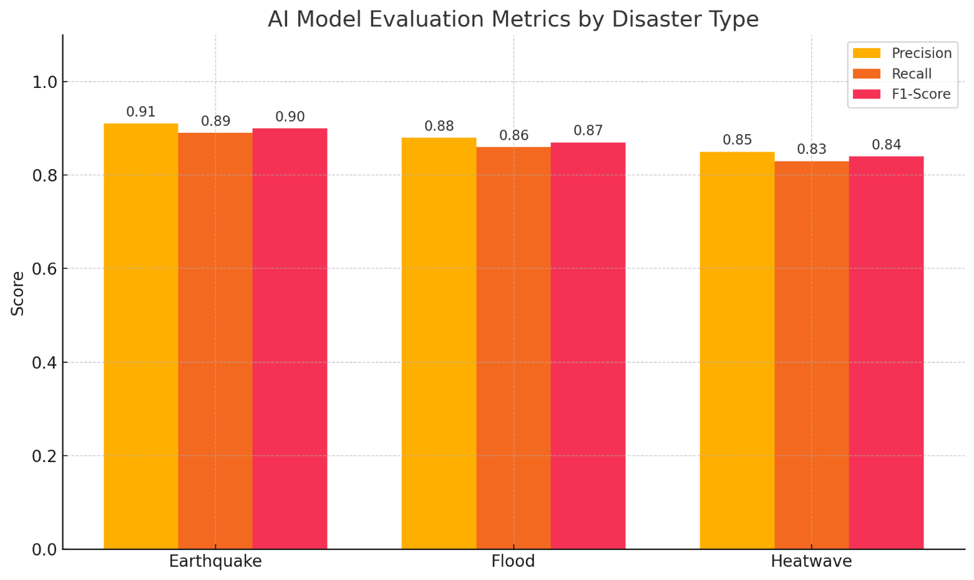

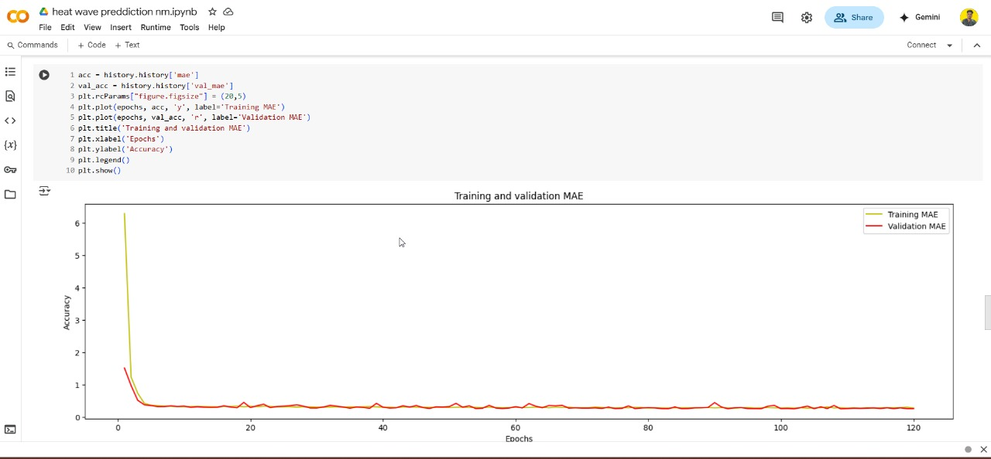

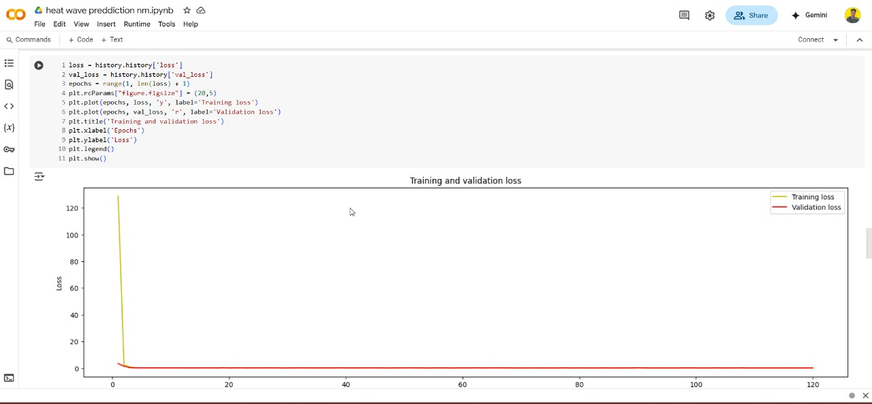

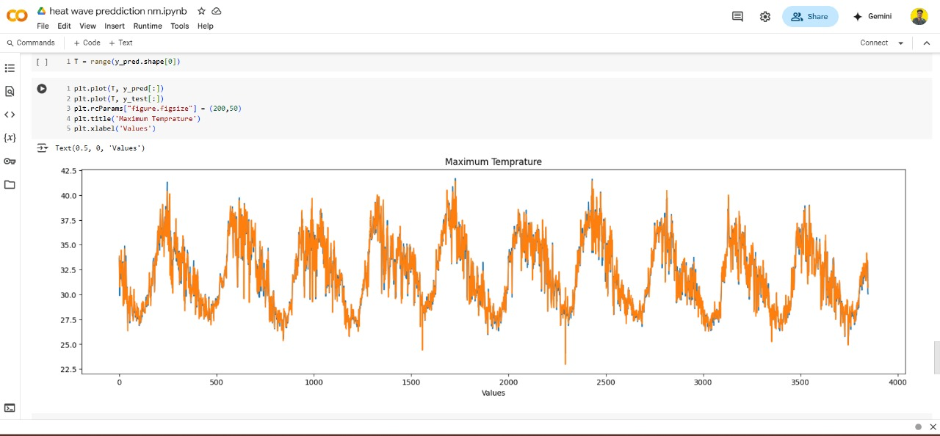

**Team Members:**

1. MayuriThilak - 311623243030
2. Sidharth R – 311623243050
3. Mruthun Murugan VS– 311623243032
4. Praveen S- 311623243037